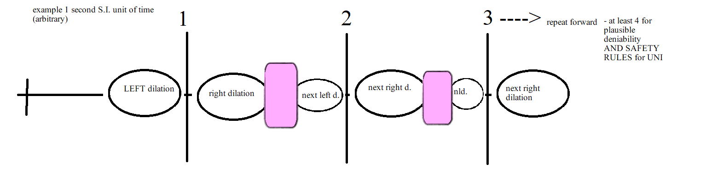

A singularity like 0 time or instant time can be surpassed or superseded or reversed or what haves you with negative energy.

Then what is time?

If fractals or using calculus and physics logic and steps/algorithms and philosophy (or whatever combo you want to use to describe algorithms with fractals that go past the end or beginning of the sometimes audio/visual simulation (digital video graphics) can lead to generation" or useage of negative energy to open wormholes and quantum BCI or quantum Medicine etc..., then time could be explained in a similar way.  
==================================================

See other documents for more images and explanations

Maybe the physics that Einstein wanted: Quantum and Gravity (relavity)

-------------------------------------------------------------------------

Kevin YK Huang 07/10/2023

Goal: Save Universe! Save Children. Bring back dead ethically! Not order of importance! And also legally expand humanity ethically and safely relative to universe's rules and hopes (which equal action!).

Rules:

Number 0 - SHUTUP - Forward only

Number 1 - Forward Only, No paradoxes or para-boxers- or pair of shorts

Number 2 - Keep Reading

Number 3 - SHUTUP - Rule Negative One is dangerous.

Number 4 - Time Crystals: Supposedly more stable with the flow of time or dangerously, the self.

Number 5 - Technique: Video fractals can show 2D representation of time 3D and time like a video game. Supposedly there is an end point or beginning point of the algorithm. If an algorithym with logic and steps and philosophy of physics/universe/laws/love/compassion can use calculus to move foward and back in the steps negative energy could be better understood to allow us a path to all physics including wormholes, Brain Computer Interfaces with out wires, food replicators (with no paradoxes), quantum medicine (everything is cured ethically), etc... .

Number 6 - Always know how to or don't until you understand. (see diagram (0,1,) That is relatively or calculateably always have more positive energy or bring back time/space (wobbles back to their original spots).

Why?

A. Frozen time = scary, unethical, dangerous hell

B. Time Travel = paradoxes = lost in space and time = time ghosts = danger = copies = death = also above (Frozen Time)

Number 7 - Some Definitions or word understandings in a contextual all respective way.

Algorithm: Logic and philsophy

Steps and Understandings

Coherence vs Decoherence: Kind of reversed maybe?

The wiggle of everthing is often thought of as decoherence. But in fact, we are all in coherence with each other, the whole universe moves forward in time safely because if not we are not safe. If not all are safe, no one is safe. So wiggles that are thought of as a challenge is actually what we have to reverse calculate with algorithms of fractals to get past singularity and have negative energy to be used to make wormholes and food replicators etc... .

If done unsafely, Alice and Bob could individually be lost to the other in space and time because the were displaced with a paradox or or not able to mathematically return to same relative "time zone".

Number 8. wormholes >|<

Leonard Susskind in a youtube video has described the wormhole as a traversable door to another door. The problems to make the doors close enough (but Safely done! Read rules again!) to open and walk through is that for some reason space and/time is expanding to the doors always drift apart (maybe) or it's due to wiggles.

So to pull the space and time together to make sort 1 door (READ RULES AGAIN!). You need an energy that's sort of "opposite" = negative energy.

Number 9. Negative Energy and Crystals (Time Crystals?)

Watch style piezoelectric cystals creatic spark or static or energy when compressed. But what is negative pressure is forced or vacuumed?

If a time crystal is more stable in time, that could mean something about the wobble or coherence is diffferent with other types of matter arrangements? Could a time crystal be more stable in a way it more easy to caculate with calculus or fractals the "proper" or "right amount (SEE RULES AGAIN)" so that negative energy is generated so we can make the fun phyics stuff.

So to create or generate or harness or tranmist or transform (the descriptive word to be used has yet to be picked) negative energy, fractals must be used to reverse or forward calculate a fractal algorithm with an ending or singularity that must be surpassed.

The "point" to surpass is a singularity. But time could be many singularities with dialiations that must cohere or mix in a regular way, not time itself or the markeable segments we use to measure and use.

Number 10. Fields and ways to use or generate them?

A time crystal then could be thought as a matter field

A space field should then exist?

A time field would then must exist and be used as a confinement "area":

For A. Quantum entanglment of space which would mean traverseable wormholes

B. Ethical and safe (READ RULES AGAIN) food quantum replicators that are sort of like star trek replicators but not the moving live or any matter site to site transporters. Just make dead food! Read rules again!

Number 11. Time

If a time crystal wobbles or is a little "less" wobbly than regular matter in other arrangements, then zero time could be thought as a singularity in a fractal animation? Sort of!

But what are inbetween the singularities of time? What is inbetween the tick tocks or Standard International units of time?

Well since now we can control or move time relativeness, we must find a way to deal with the spots inbetween time segments. But either side of singularity has a fractal animation or maybe dilations to confine the time segment. THEN! what are the spots between the dilations that is on one "side" of a time segment? Could it be a time field that must be calculated? If dilations are though as waves like SINE then some simple way to think about it would be interference that keeps time sane!

Numbeer 12. Food replicators

Timing and orbitals or electron bonding fields layer by layer (SAFELY: READ RULES) in a confinement field!

Number 13. Quantum Medicine:

Ex. Neurodegenerative: Use fractals to generated back the possible configurations of brain from dna and current snapshot.

Then slowly arrange or heal.

Ex. Aging, basically the same.

Ex. Anything medical! GO!

**MORE**

two types of time

relative to self or relative to other point

since space diffuses maybe with out containment field...for shit like replicators that make FOOD safely...READ THE RFUCKING RULES NEWBZ.....

Then in case 1

time will diffuse or the dilations between time will diffuse or the space so that time will seem consistent

but if time is relative to different points...hahah shit fucks with with always anyways....

-----------------------------------------------------

If you use UAP tech, please becareful...READ THE FUCKYING RULES NEWBz....

TIC TAC planes/ 2d planes of surface can always PULL if door between leads to GRAVITy from A MASS....

WHY NOT BLACK HOLES.... CHEAP! and DANGEROOUS TO get close... SPACE MINES!

But if you use SPACE / TIME / MATTER DILATIONS... of fields...with fractal re ordering of DENSITY... yeah you can have instant G or instant -G, but FUCK YOU...DANGEROUS... JUST DO CHEAP GHETTO EASY Way... unless you got ballz... son!

**IONIC WIND for lift and parachutes**NIKOLA TESLA TEST LOCATIONS

-COLORADO

- dry, BUT LOTS OF TREES? - SOME SORT OF TREE EMISSION ACID OR OIL... POSITIVE CHARGE acid?

COULD THAT BE ONE WAY TO HELP WIRELESS ENERGY A LA tesla...THE ORIGINAL dudeR!?

THE ACID IS A GUIDE FOR THE STATIC OR omni DIRECTIONAL wireless energy

------------------------

Then use this to figure out how to push atmosphere with ionic wind... hard partly figured out... it works in space... less atmosphere or shit in the way for the static to get to where it needs to go?

MORE TO THINK OFFFFFFFFFFF.....U.... US FOOL US... magic time boyssss hahahaha **AIRGUN**  
  
AIRGUN SLASH RECOILLESS RIFLE

direct air back with special catridge that works like slide side lever air rifle design

Direct air or something back to deal with horizontalish recoil...then use other shit for other recoil.... the microjet turbines

CATRIDGE primer is air hole for exhaust gas to help reduce felt recoil...

Primer is now a loop or ring around the original center primer... it's super peizo electric material... with safetey locks

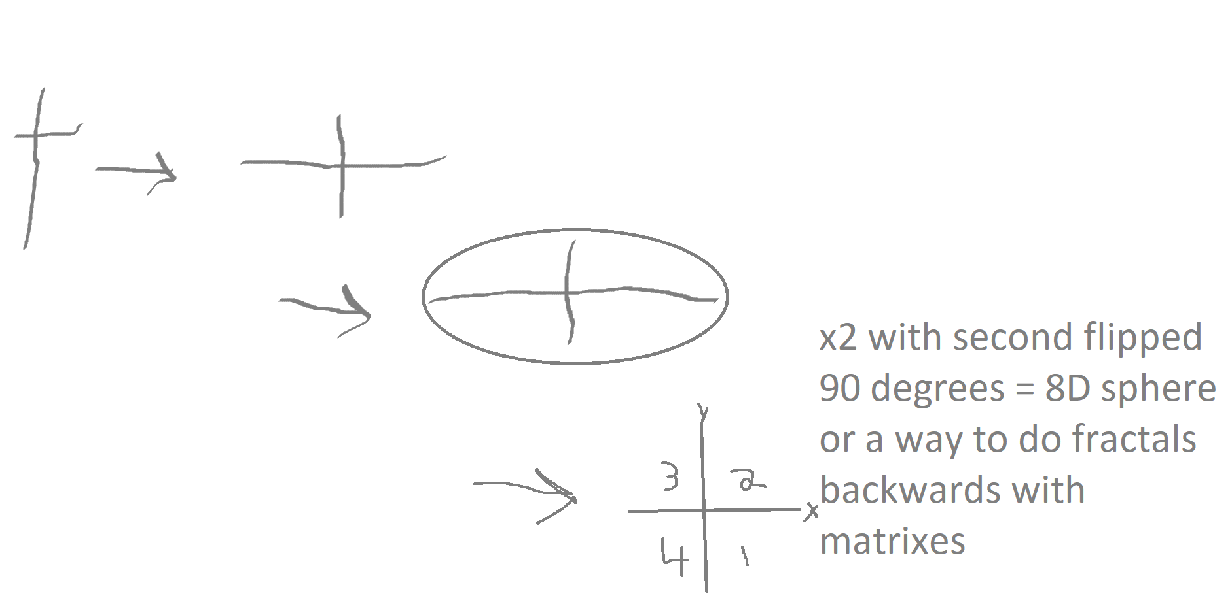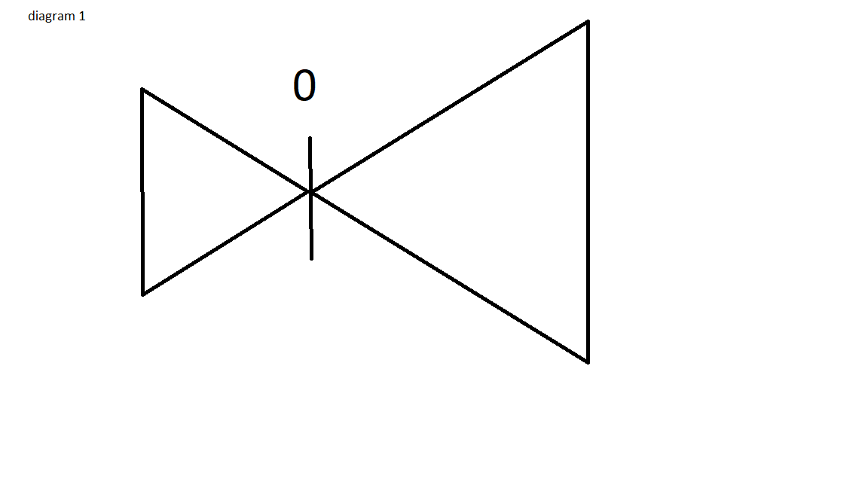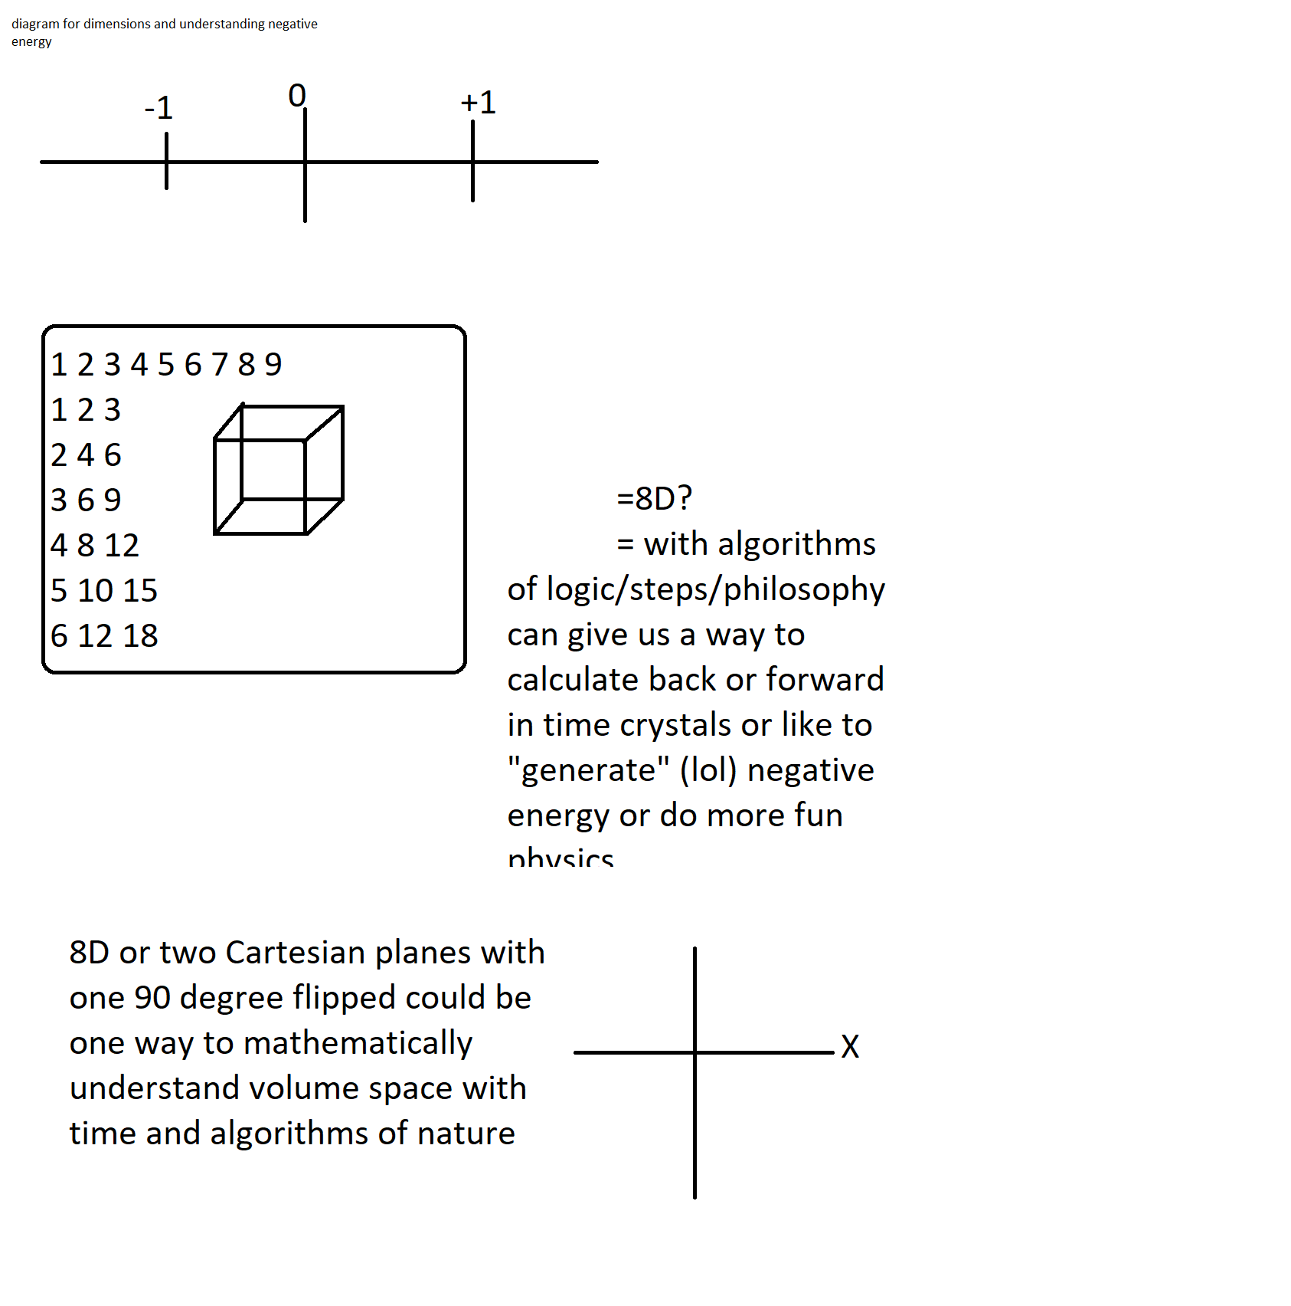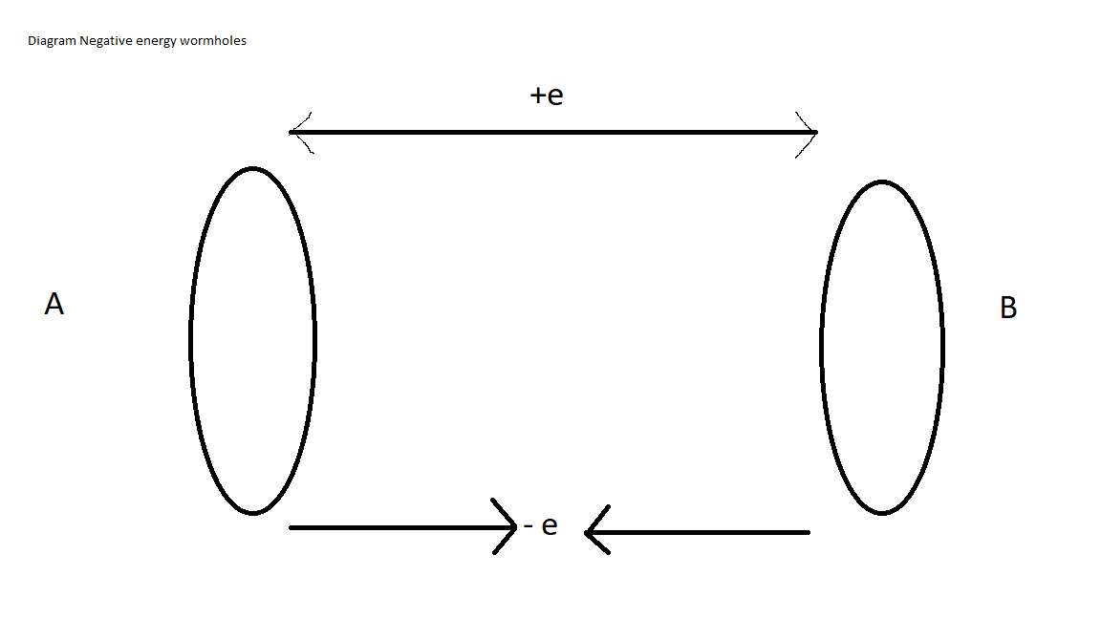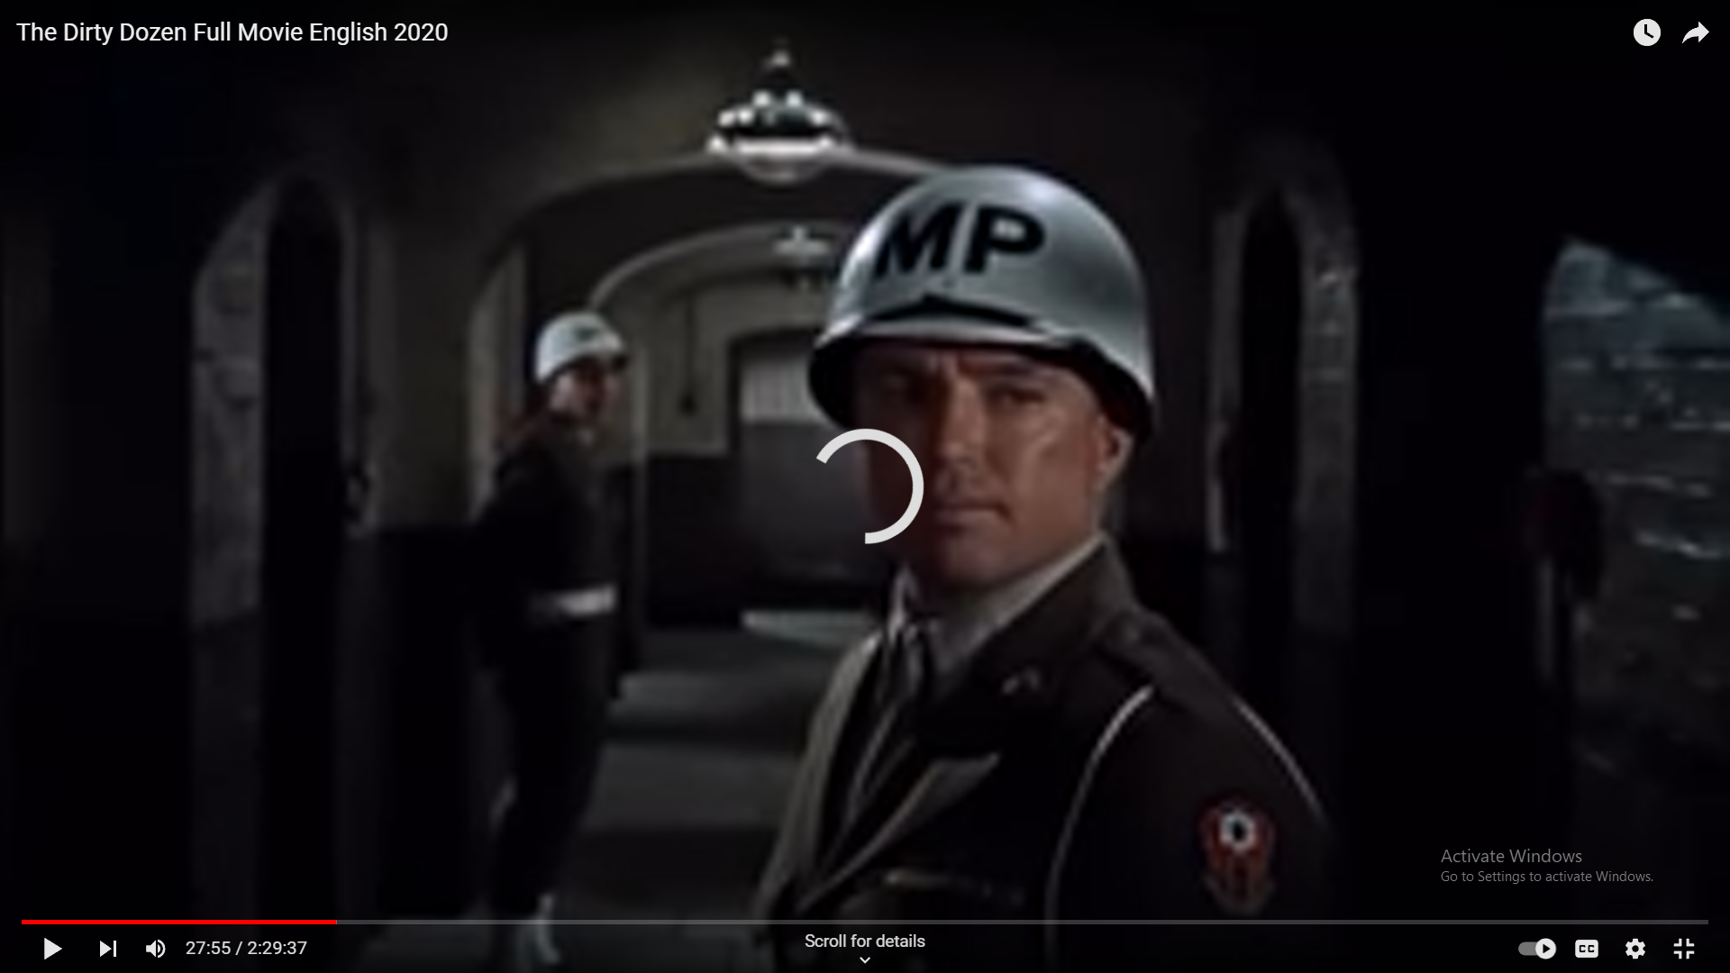

FROM OR FRO or FOR – jokez version specifically vs PRATIK – eASTER Eggzzzzzzzzz

===============================

If time, or the chosen SI unit (here 1 second), is always surrounded (if thought with a 1 dimensional line lol) with dilations or or wiggles or energies that can be used to shift, for example matter back in time or through space hopefully near instantly and not too fast lol, then the dilations will always be surrouned on the other side by a mystery scenario.  
  
  
This area of the 1 d line will have to negotiate with the different dilations or wiggles or whatever so that they somehow diffuse or find a way to balance out (YING FUCKING YANG TINA TURNER).  
  
One idea was that negative energy is the opposite somehow to positive energy but they are neither created or destroyed even when changing from one side of this energy barrier to the other side (the barrier can be a singularity in time also – zero time).  
  
  
  
  
A forumla could now be guessed....  
  
  
  
B = 1 second = L/R * ((L+R) / Z)  
  
  
Let’s try to figure this out...  
  
The above is in ways a algorithm or fractal succession of steps with science philosophy.  
  
  
  
What we will find here is what is between time segments that we choose earlier (1 second).  
  
  
Let’s also forget the first segment or lack of, 0 time and only move forward (as is the law of nature or the universe – fuck with it and you will die you POS trash fucking humans).  
  
  
  
X = previous time unit  
y= unit of measurement  
 Together x+y just says a repeating forward time pattern  
  
  
z = ration of dilations from the left and right side that affect the time or singularity in the middle like wiggles or negative and positive energy balance with fractals and time crystals and negative pressure example as seen in a reverse piezo electric crystal setup.  
  
  
a=next ratio Variable a or next ration can continue on like x+y

Again let’s forget soemthing, 0 is not of concern right now, just the first few time segments.  
  
B for now will be used to describe a balance area or sceneario

(((d/dx)^x+y))+((-(d/dx)^x+y))/z) + (((d/dx)^x+y))+((-(d/dx)^x+y))/a) = B  
  
  
The plus sign between the d/dx^x+y and -d/dx^x+y is a metaphor of energies in ways that show a singularity, here a time segment pattern (predictable?)  
  
  
z is some mystery ratio that represents a time segment, ratio being some sort of constructive and desttructive interence fractally in many dimensions maybe 8D? A 2x cartesian plane where one is flipped 90 degrees horizonatally on the vertical axis for simplicity.   
  
a is the next ratio  
  
  
  
Let’s now represent the left and right sides of a singularity:  
  
(((d/dx)^x+y)) could equal the LEFT side or L   
  
and  
  
((-(d/dx)^x+y)) could represent the RIGHT side or R or a singularity  
  
  
  
If we think continually as a fractal recrusive way.... Then a 1 moment or 1 second chosen SI unit could then really then be thought of as affected by the wobbles or energies or other around it as if the full 1 second is itself a singularity.  
  
  
So ....   
  
  
(L^(x+y)) x (((L^(x+y)) ((R^(x+y)))/z) x ((R^(x+y)) = observable moment?  
  
  
Here, multiplication is a metaphor of a relational affect like before!  
  
  
L: L+ R / z : R = B another way  
  
  
But if the Left R and the Right R are relational or important to each other and the whole of the fractal then.....  
  
  
L/R X (L+R/z) = B